**Function Pointer assignments**

**Mandatory**

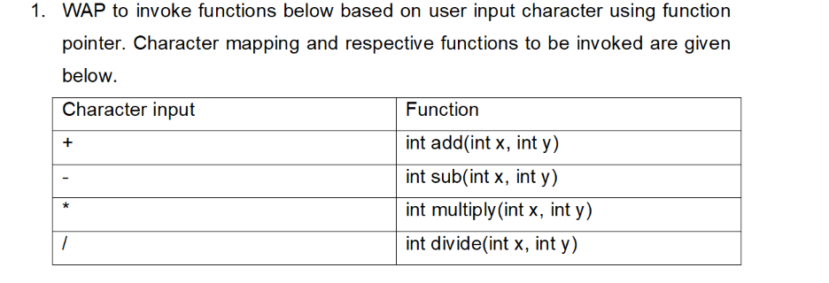

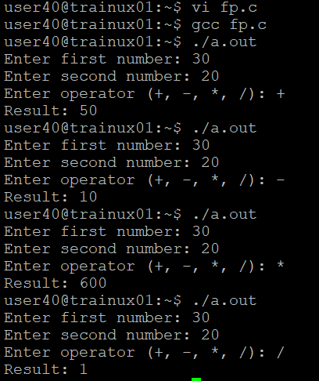

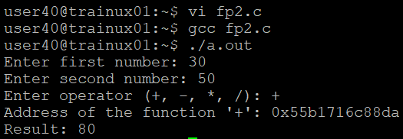

**3. Extend Q1 to include a function below which takes a function pointer to a calculator function and one integer (value = 10) as arguments and shall invoke the given function with required arguments.**

For the second argument read input from user. Return the result.

int invokefunc(<function pointer as argument1>, int val1);

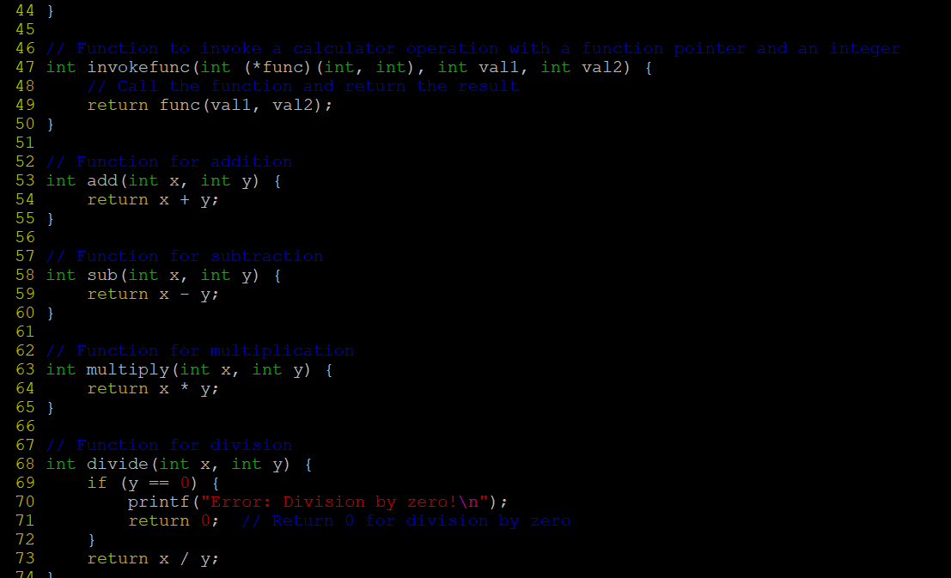

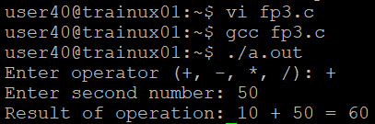

**4. Extend Q1 to define an array of function pointers and invoke them based user input character.**

